CS550 Project #4  
Xiaoru Chen  
Email: chenxia2@oregonstate.edu

A Screen shost from my program: 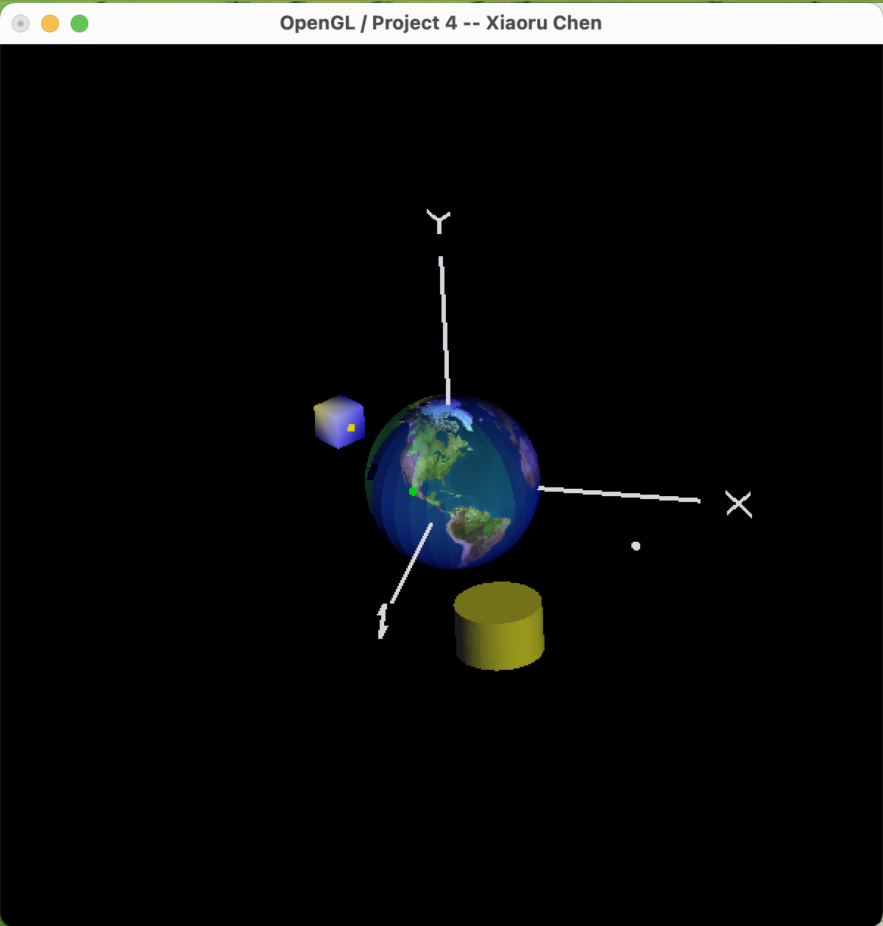

The link to the Kaltura video:

<https://media.oregonstate.edu/edit/1_m5vlosjv>